**Businer Networking Application**

# INTRODUCTION

Businer is a platform which brings the Indian start-up ecosystem at your fingertips. An online business social networking application that connects Entrepreneurs, Investors, Mentors and other like minded people. Start-ups are here to change the world, but they need an engaging ecosystem to grow. Many start-ups’ success depends on their ability to network. Businer seeks to create an online ecosystem of Entrepreneurs and start-ups for the tycoons in the making and to help strengthen the economy.

The project is composed of Web and Mobile Application for social network based system.

# KEY MODULES

* Listing start-up pitch
* Start-up deck
* Share the Listing on Platforms
* In app messaging
* Discussion forum
* User notification
* Entrepreneur platform
* Investor platform
* Mentor platform
* Cross platform sharing
* Social feed posting
* Location based feeds
* Category based feeds
* Traffic management
* Manage user profiles
* Track start-up performance
* Payment Integration
* Insight details
* Social media notification
* Profession Management
* Start-up and user verification
* Point system
* Marketplace Strategy
* Local business platform

# DEVELOPMENT MODULES

Application development is based on 3 Roles

* Mobile Application : Android & iOS Development
* Web Applications
* Backend Application

**KEY FEATURES**

* Notification services
* Payment Gateway
* Investors Dashboard
* Entrepreneur Dashboard
* Email Services
* Account Verification
* Launch start-up Campaigns
* Performance Graph Ratio
* Start-up growth rating
* Filtration

**FRONT-END APPLICATION FEATURES**

# 1. SIGN UP

Registration can be done using social media auth verification

For Auth verification these below Features will add in registration on phone verification such as:

* Social Account sign-In – Facebook, Twitter, Linked In
* Account Verification
* Email or mobile number otp verification – Sign Up email or mobile number

Note - *OTP - One Time Password

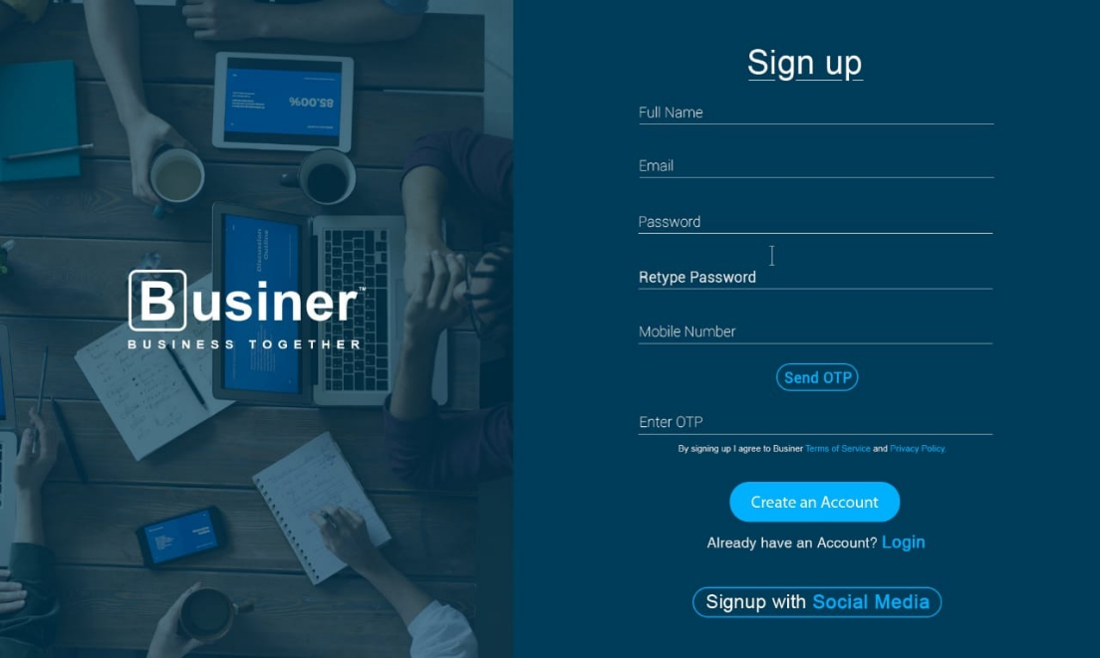

WEB UI

MOBILE UI

# 2. SIGN IN

The application must have login activity with a field for a username and password. The user will be able to login if he confirmed his email credentials.

For Auth verification these below Features will add in login on phone verification such as:

* Email Otp verification
* Forgot Password
* Social Media Account login – Facebook,Twitter, Linked In
* Email Verification Sign In

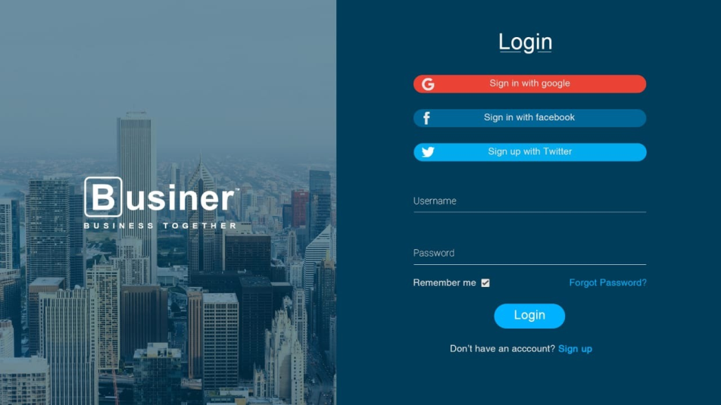

MOBILE UI

WEB UI

# 3. WEBSITE HOME PAGE

Display the start-up details on card view where view is integrated with basic details. Clicking the start-up will open the start-up pitch which includes brief details, videos and documents of the start-up. Below the Image is a reference. Users can check outstart-upsaccording to their interest.

WEB UI

MOBILE UI

## 3.1. FILTRATION

Users can filter the startups by using filtration module .Here the filtration can be done by different categories like industry, size, recent, trending and location.

**3.2. STARTUP PITCH**

It includes brief details, videos and documents of the start-up . Below Images are for reference.

WEB UI

MOBILE UI

# 4. SOCIAL NETWORKING PAGE

Social networking/feed page allows users to share their ideas, photos, videos, posts and discussions to the community as a whole or people of their interest. Users can also upload status/story (24 hour time limited post).The page facilitates the function of #hashtag which provides the user with feeds of their interest. Users can interact with each other personally or converse in a group. The interaction link members of various networks and may help to both maintain and develop new social and

# 4.1 FILTRATION

Users can filter the feeds by using filtration module .Here the filtration can be done by different categories like industry, profession, trending and location.

# 5. POSTING

Users can post pitch, photos, videos on stories and feed

# 6. NOTIFICATION

Notifications updates the user of their interest and activities

# 7. MESSAGING

In app messaging allows users to communicate privately with individuals and openly in groups

# 8. USER PROFILE PAGE

# User profile page allows users to view their posts, display their achievements, write about themselves and manage their networks.

* User feeds
* Activity
* About
* Network insights

# 9. ONLINE DOCUMENT SUBMISSION

Entrepreneurs and start-ups must submit their document on Requirement Basis.



# 10. PAYMENT GATEWAY

Payment Gateway module is used for users for promotion and add posting to Transfer the funds using below any payment gateway.

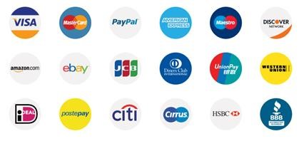

# 10. 1. EMAIL VERIFICATION

Once the Investor payment is completed the invoice bill and Dashboard panel link will be emailed to registered email Id for Next process of crowd fund business over the company and investors.



USER INTERFACE/ USER EXPERIENCE

Businer UI/UX designs of web and mobile application has been constructing by intense research and after studying the mindset of the audience. The UI/UX has been created especially to adapt the modern day social media used by the people, henceforth It is very friendly to use and understand the modern day platform of Start-up ecosystem.

SERVERHOSTING

Amazon web services/Digital ocean

TECHNICAL AND OPERATIONAL FEASIBILITY

For this project, we will be using:

* Java & XML for the mobile application using Android Studio as it is the official IDE for android applications’ developing.
* For the backend, we will be using MYSQL as a database engine & Laravel as development Framework, as it is known for its high reliability, full-featured, and self-contained. More than that, it is the most suitable database engine to use with an android application.
* Web development PHP on function development and design part HTML

➢iOS We will be using Swift Objective-C.

PROGRESS

We have completed 30% of the project including backend and frontend, the expected date of completion is 1stSeptember, 2020.

REVENUE

Source of Revenue –

* Promotions
* In app sponsors

CONCLUSION

We Hope that you will find our Project Proposal Document satisfactory and look forward to working with you.

Please Contact Us more any further details.

E- [info@businer.in](mailto:info@businer.in)

M- +91 7676002116, +91 7406191211

(Certain images used are for reference purposes only)

PS- Please find the Adobe XD prototype in the given GitHub link.

All images and contents are solely owned by BUSINER.

THANK YOU.